Day 6 – CLI ( EOM DAYEON )

1. ares-generate -t webapp videoApp => Create a web app

2. ares-package /home/eom/videoApp -o /home/eom

3. ares-install --device emulator /home/eom/com.video.app_1.0.0_all.ipk

4. ares-launch --device emulator com.video.app

5. ares-inspect --device emulator --app com.video.app

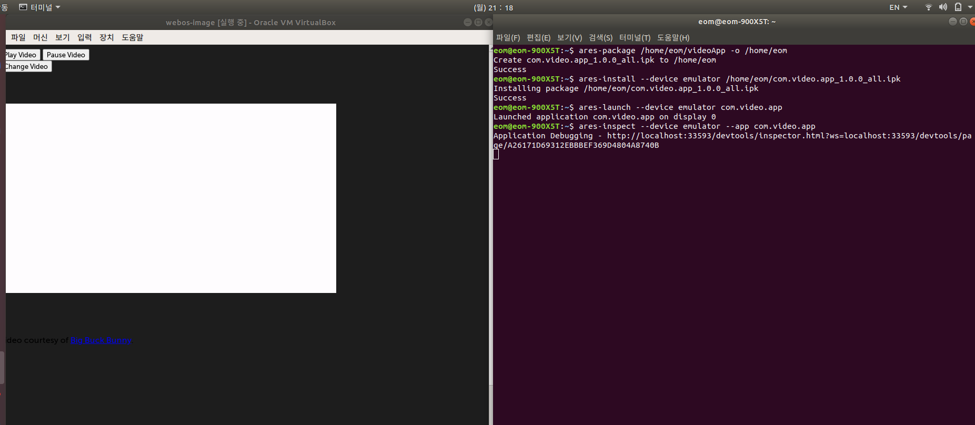
<Run Screen Before Pressing the Play Button>

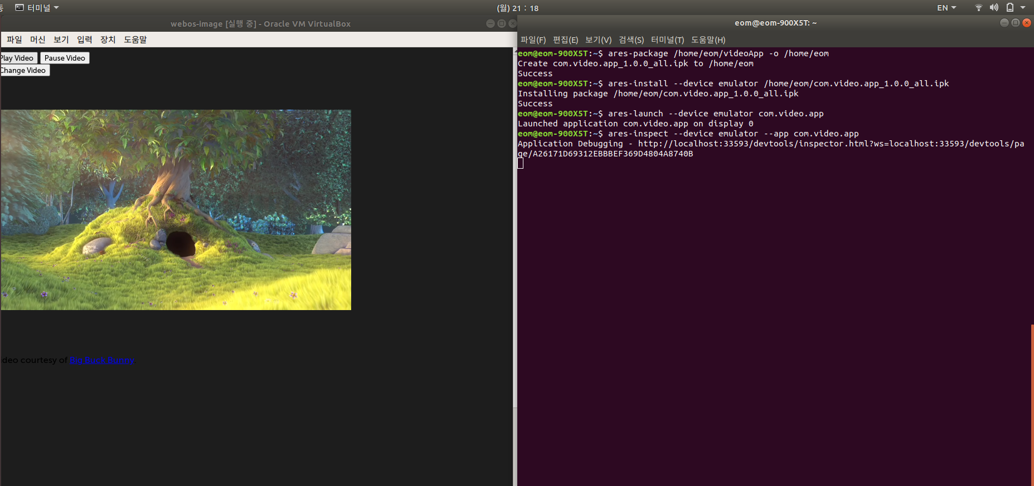
<Screen pressed the Play button>

<Pause button pressed >
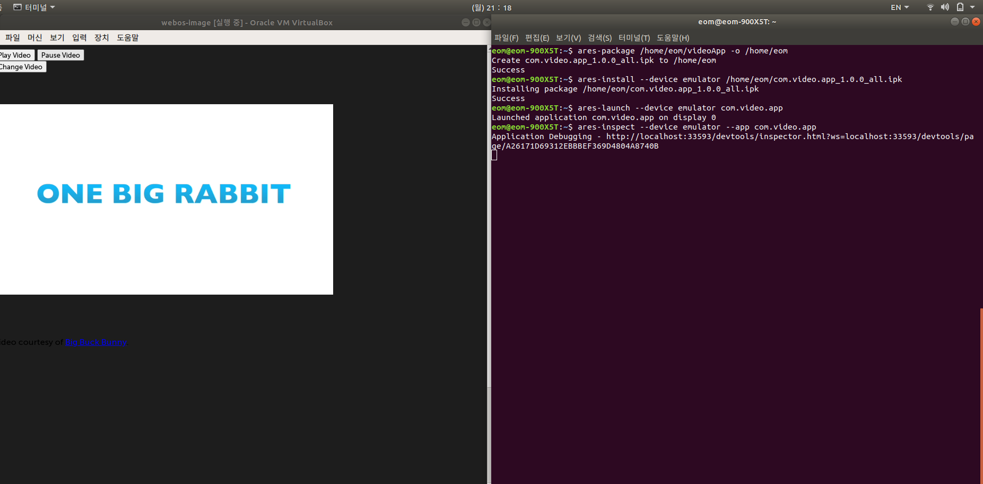
<Change Video button pressed >

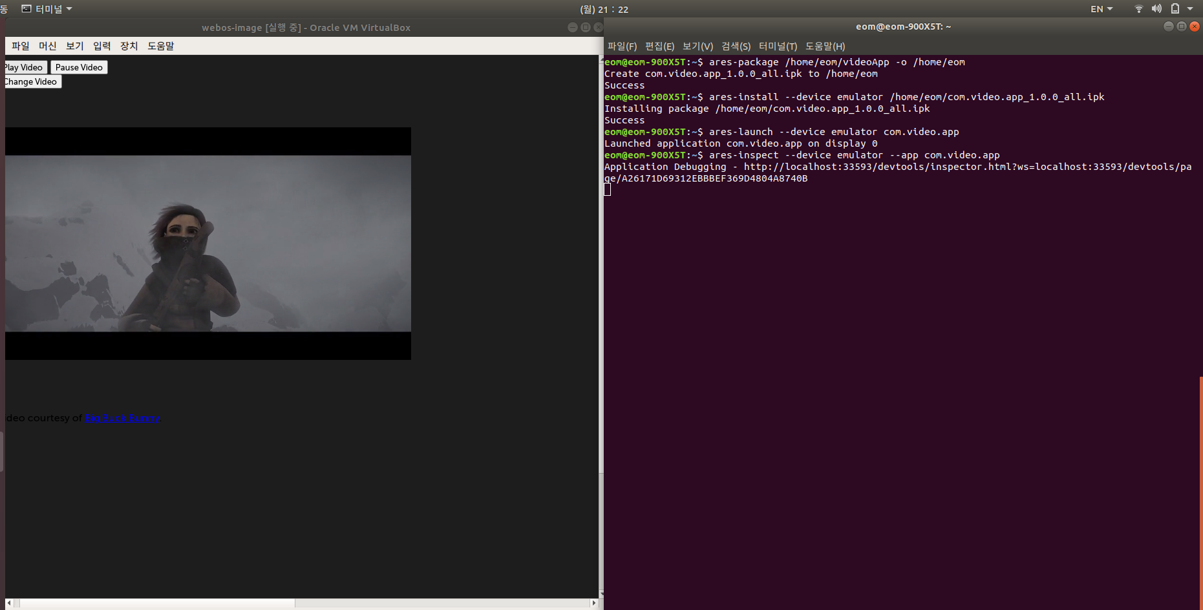
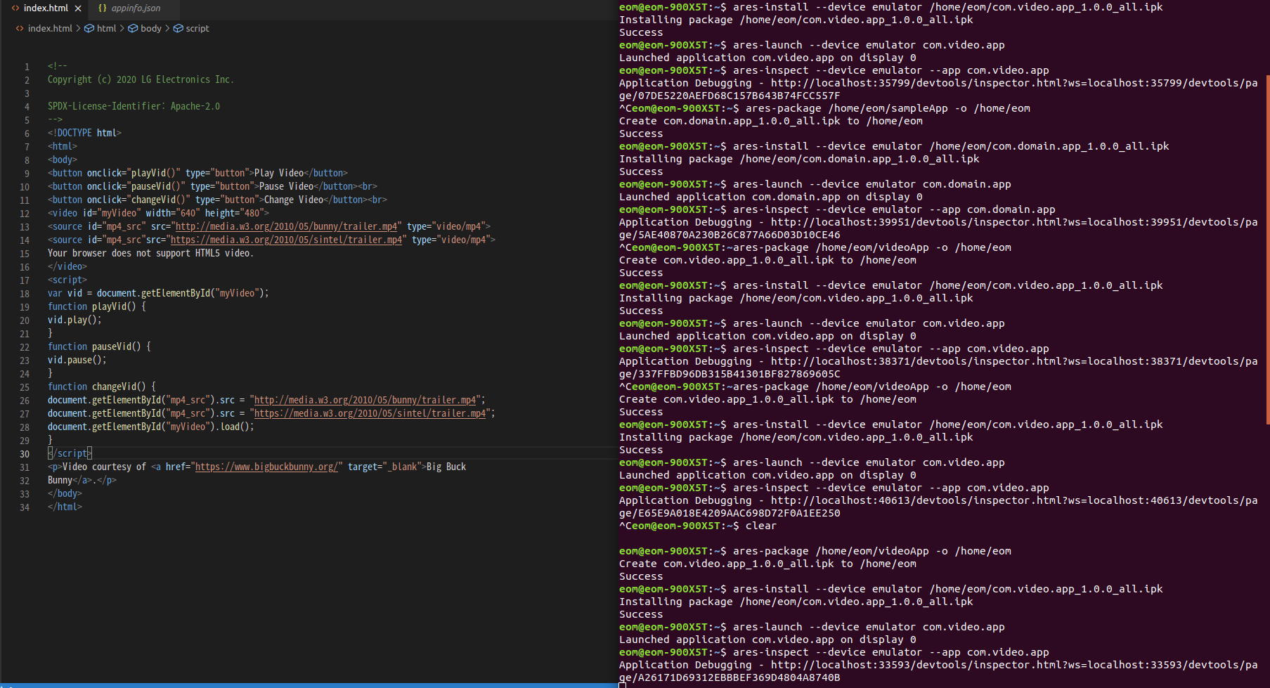
<Video web app execution html code and terminal execution screen>

